The following screenshot displays the Transliteration feature integrated in Demographic Details section of Registration work-flow:

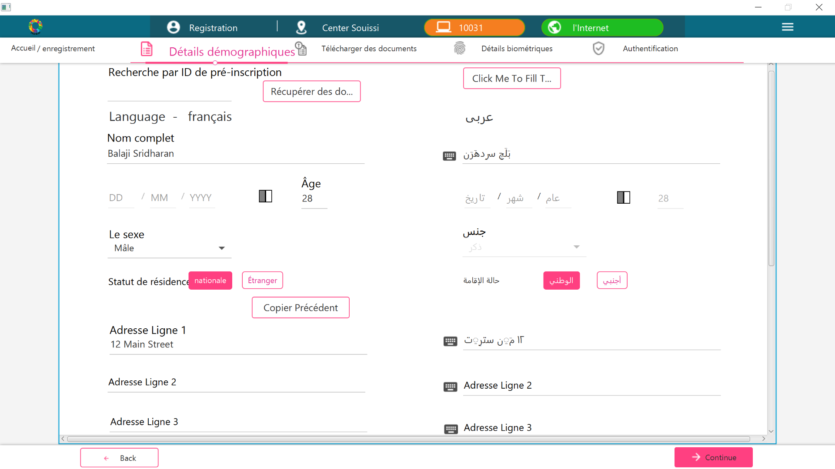

In the above screenshot, while typing the data in “Nom Complet” text field, the text had been transliterated to secondary language (Arabic) from primary language (French).

For numeric fields, say Age, the text is not transliteration as part of requirement. Similarly the drop-down fields are not transliterated but the corresponding value in secondary language is selected based on the code of the selected value in primary language. In other words, “Male” is selected in “Le sexe” drop-down. In its corresponding secondary language drop-down, the value is selected based on the code provided for Male.